Rutherford and Pickering at Havelock School
www.theprow.org.nz/.../rutherford-and-pickering-at-havelock-school/

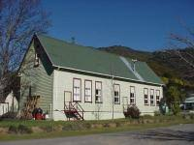
In the last quarter of the 19thCentury and the first quarter of the 20thCentury, Havelock School was involved in the early education of two stellar minds, both ...

Havelock
www.theprow.org.nz/places/havelock/
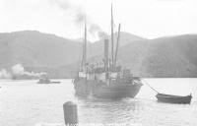
27 Sep 2018 ... Havelock was a goldrush town which, for a short time, nurtured two of New Zealand's greatest scientists: Sir Ernest Rutherford and Sir William ...

Havelock's General Store
www.theprow.org.nz/yourstory/havelocks-general-store/
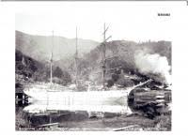
9 May 2018 ... The colourful store building painted with tuataras in Havelock's main street has a long history.
James Raglan Akersten photographer
www.theprow.org.nz/people/james-akersten/
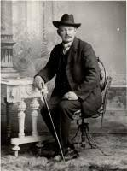
Landscape and studio photographer, James Akersten spent many years living and working around Havelock and Nelson.

Ernest Rutherford's early life
www.theprow.org.nz/yourstory/ernest-rutherford-early-life/
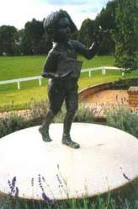
22 Jan 2010 ... Even though Ruapaka Stream was near enough to Havelock, Ernest's father did not come home during the week, only returning to Havelock on ...

Life in Canvastown and the Wakamarina
www.theprow.org.nz/society/canvastown-and-wakamarina/
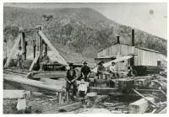
The family moved to Havelock and Tommy began working at the Kaituna mill for William Brownlee. Using bullocks, Tommy and Bob Anderson, with head ...

Timber Pioneers - Brownlee of Marlborough and Baigent of Nelson
www.theprow.org.nz/people/marlborough-nelson-timber-pioneers/
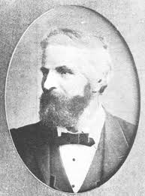
25 Jan 2019 ... Brownlee's Mill, Havelock, The Nelson Provincial Museum, Tyree Studio ... (2002, July 27) Havelock 'lokey' reminds us of Pelorus timber days.

