Havelock Museum Newsletter
Hi All
This newsletter will come out as regularly or sporadically as we can. We would like to make sure that the people interested in Havelock Heritage are informed on what is happening.
Your Committee
The committee consists of: Chairperson: Linden Armstrong, Secretary/Treasurer: Rita Jacobson, Committee: Joan Huddleston, Ian Cameron, Pam Mullis, Marion Marfell, Merriann Stewart, and Logan Coote who have been meeting once a month discussing issues relating to the Museum and Heritage around the Pelorus area.

This last year has had its ups and downs especially regarding Covid 19 and the lack of international tourists meaning we need to make sure Kiwis pop into the Museum on the way through and on their holidays.

The Flea market has been doing well on Saturday mornings when the weather has allowed it to be open. It is a similar story with the donation box for the museum. More donations mean it is easier to help preserve our history

Museum Redevelopment – From the Jack Shand Building (JSB) to a Social History Museum

Lotteries has provided us with $20 000 and Rata $15 000 to start this process. The toilet on the back of the JSB has been built. Sally Papps who worked with us on our redevelopment project on the Museum, is working with us again. We have had several meetings with her.
There was a very generous donation of $25,000 by the Awhero Nui Trust, after they had visited Havelock Museum and saw what we had done and wanted to help with this.

Also, a big thanks goes to Ian Williamson of Havelock Hotel for another four weeks of Friday night Pub raffles which raised $480.

Further applications to funding organisations are to be made as the project develops.

The plans for the interior of the building have been received. The MDC granted consent but work will not commence until further funds are raised, so, in the meantime, our Flea market is still open on Saturday mornings (weather permitting) for all your weekend bargains.

Donations
We welcome donations of objects relating to the history of Havelock for the museum. We also welcome to hear about what people have in their own collections if they would like to share copies or photos of the objects for the collection. Private and family collections of objects held outside of the Museum are a great resource and we never know what might turn up.
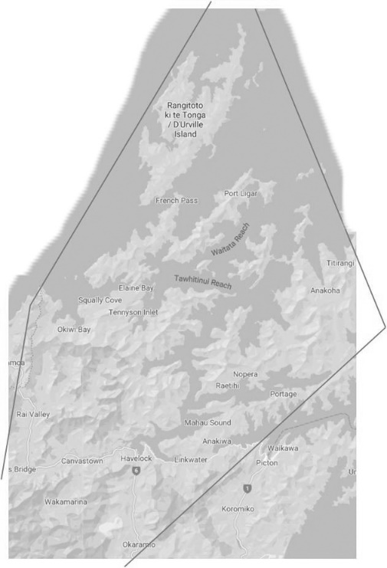
Collecting Area
We have worked out that the Pelorus collecting district stretches from Okaramio to the Rai through to Stephens Island and back in a slight triangle missing Queen Charlotte Sound which should be Picton’s domain, and then overlapping back to Okaramio then Pelorus Valley behind and to Pelorus Bridge. We share some of our wide area with Picton, Rai and Canvastown all who are collecting archives.
We are interested in local people’s family trees as part of the redevelopment, we don’t know exactly what is going in it as yet but we know we want to show the history of the community through its people and businesses as part of.
Enquiries
We get many enquiries from the public about the history of the area and we aim to respond as soon as possible. One of these was about Thomas Wells and the Pelorus Cemetery. We Found out that the Couper’s private cemetery at Pelorus was the only family there and that Thomas was on the Pelorus Death Register along with others who were buried in the Havelock cemetery, so, we believe he was buried with his family there until more information is found.
Another query was regarding the Whatanihi Guest House.
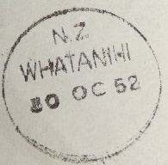
Whatanihi Seaside Farm in the Pelorus Sound, comprised 600 acres of freehold with a Guest House nestled at the foot of the hills with its own private bays. The facilities included accommodation for about 40 people. There was a post office/telegraph service from 1925 - 1959. This image shows a post office stamp dated 1952.
Nancye Scott became the owner in 1965 (previously owned by D.P. Highet) and took up residence in 1970 with her companion David Hughes.

The Guest House accommodated about 40 guests, the sleeping quarters being in a separate wing. Some bedrooms had hot and cold showers, baths and washing facilities, septic tank sewerage and 230 volt A.C. electric power. Meals were substantial and home cooked usually 3 – 5 courses served hot in the comfortable dining room. A large lounge with open fireplace, a big sun verandah and a reading-room at the disposal of guests.
This information was provided by Nancye’s daughter Anne Rowlands.

Calendar

Joan has done it again and created a wonderful calendar showcasing some of the region’s history in photos. The price is just $15 with proceeds going to the Havelock Museum. It can be purchased from Four Square, the Garage, the Museum Fleamarket or by phoning Joan on 03 5742435.
We would love to see more people involved with heritage of the Havelock area.
Contact details are on our Website: https://www.havelockmuseum.nz/

